

SMALL BITE OF THE MONTH – JULY 2010

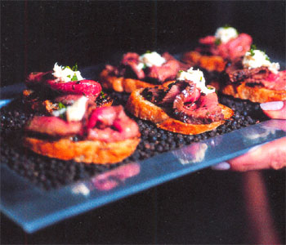
Roast Beef Crostini with Horseradish Cream

¼ lb. thinly sliced roast beef
1/8 c. undrained horseradish
½ c. sour cream
2 scallions chopped
¾ t. salt
¾ t. coarse ground pepper
6 crostinis

Stir together the horseradish, sour cream, scallions, salt and pepper in a bowl. Top the crostinis with slices of roast beef and top with the horseradish cream. Garnish with parsley.

To make it even simpler, use a good, prepared horseradish cream.

I had a similar small bite at Morton’s. Instead of the roast beef, they used a “melt in your mouth” beef tenderloin and topped it with blue cheese.

