SMALL BITE OF THE MONTH – OCTOBER 2010

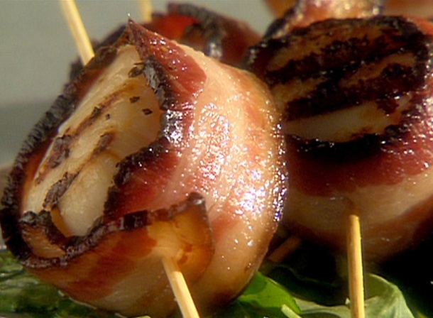
Bacon and scallops always pair beautifully, but it's the mixture of sugar and spice that transforms these easy-to-make hors d'oeuvres.

Scallops with Spiced Bacon
Makes 28 small bites

Ingredients:

6 tablespoons packed dark brown sugar
1 tablespoon curry powder (preferably Madras)
1/2 teaspoon cayenne
14 bacon slices (3/4 lb)
14 large sea scallops (1 lb), tough ligament
removed from side of each if necessary and
scallops halved

Special equipment: 28 wooden toothpicks

Preparation:

Stir together brown sugar, curry powder, and cayenne in a bowl until combined well.
Cook bacon in 2 batches in a 12-inch heavy skillet over moderate heat until some fat has rendered and edges begin to brown but bacon is still flexible, about 2 minutes per batch. Transfer bacon to paper towels to drain and cool.
Preheat broiler and lightly oil top rack of a broiler pan (do not line with foil).
Cut bacon slices in half crosswise. Divide sugar mixture among slices, spreading evenly and lightly pressing to help it adhere. Place 1 scallop half, cut side down, on each slice of sugar-coated bacon, then wrap bacon around scallop and secure with a toothpick. Transfer to oiled rack of a broiler pan.
Broil scallops, bacon side down, 4 to 5 inches from heat, turning over once, until bacon is browned and scallops are opaque, about 6 minutes total. Serve immediately.

Pair this recipe with a fruity white with a strong body, such as a New Zealand Sauvignon Blanc.

