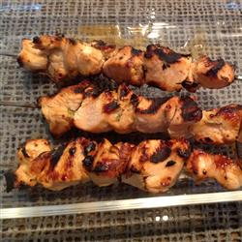
Rosemary Ranch Chicken Kabobs

Prep Time: 50 Minutes Ready In: 1 Hour
Cook Time: 10 Minutes
Servings: 6

• "This rosemary ranch chicken recipe is so delicious, tender, and juicy the chicken will melt in your mouth. Even the most picky eater will be begging for the last piece."

• INGREDIENTS:
1/2 cup olive oil
1/2 cup ranch dressing
3 tablespoons Worcestershire sauce
1 tablespoon minced fresh rosemary
2 teaspoons salt
1 teaspoon lemon juice
1 teaspoon white vinegar
1/4 teaspoon ground black pepper, or to
taste
1 tablespoon white sugar, or to taste
(optional)
5 skinless, boneless chicken breast
halves - cut into 1 inch cubes

• DIRECTIONS:
1. In a medium bowl, stir together the olive oil, ranch dressing, Worcestershire sauce, rosemary, salt, lemon juice, white vinegar, pepper, and sugar. Let stand for 5 minutes. Place chicken in the bowl, and stir to coat with the marinade. Cover and refrigerate for 30 minutes.
2. Preheat the grill for medium-high heat. Thread chicken onto skewers and discard marinade.
3. Lightly oil the grill grate. Grill skewers for 8 to 12 minutes, or until the chicken is no longer pink in the center, and the juices run clear.

