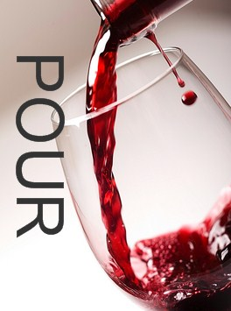
Reyes Winery
Agua Dulce, CA

We discovered a winery in Agua Dulce (about 40 minutes from Burbank on the 14 freeway heading to Lancaster/ Palmdale) through a website LocalWineEvents.com. We had been to a winery in Agua Dulce about 10 years ago and thought this might be the same winery under different ownership. However after doing some Internet investigation we found that this is a new winery in the same neighborhood. The tasting room has been open about a year. We also found a Yelp deal where we could purchase a $50 certificate for $30. Yelp had some pretty good reviews and since it was a beautiful day, we grabbed our certificate, packed a picnic and headed to the winery. When we arrived we were greeted by the winery dog, Oso, a big and gentle German Shepard. Since we were the only people in the tasting room for a part of our visit, we got a lot of personal service. All of their wines are estate grown. The 16-acre vineyard was planted by Robert Reyes and his family in April of 2004, and consists of five varietals: Cabernet Sauvignon, Merlot, Syrah, Chardonnay, and Muscat. They had all of their wines available to taste. The tasting is $7. Not a bad deal! Their Chardonnays are not your typical Chardonnay. They were very crisp, unoaked, clean and fruity. Their whites tend to be on the sweet side, not my preference but they were well produced. The reds had some interesting bouquets and flavors. One of the interesting things we found true of both the reds and the whites, there seemed to be a big style change in the varietal from year to year. We bought a couple of bottles to bring home plus one for our picnic.
Under a tree, they set up a table and chairs so we could enjoy a nice picnic. Oso seemed to be interested in our picnic too! Good wine,good food and nice vistas! We can't think of a better way to spend an afternoon.

We found the wines at Reyes Winery superior to the wines we remember tasting at the neighbor winery. As one of the other Yelpers commented, the tasting room could use more personality.The walls are white and the only thing on them are paintings that were painted by the owner, Robert Reyes. In fact, each year one of his paintings is chosen to be used on their labels.
We would definitely recommend this winery for a fun day trip. Be sure to bring your picnic because they don't sell any food.

