Pour Haus Wine Bar
1820 Industrial St.
Arts District, Downtown Los Angeles
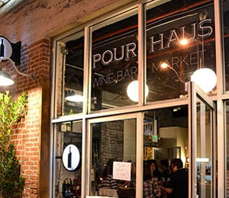

If we were to open a wine bar, this is what it would be like! A simple, unpretentious neighborhood gathering place. They have Tuesday night trivia and a monthly Wine Comedy night. " 10 wines, 30 questions, 100 laughs." You can buy by the flight, glass or bottle. Happy hour runs daily from 4 to 7 and they have a selection of food and wine for $5. The selection of wines looked better than the average "happy hour" offerings. They also have a bunch of board games. Everything about the place encourages you to come in, sit down, relax, grab a bottle of wine and stay awhile.

Opened early 2012
They are licensed as a wine shop so that allows them to offer bottles at a better price. You can order a bottle to take home or to drink there for the same price.

We visited on a Saturday after a long day of walking around the Brewery Artwalk. It was early and we were one of 2 or 3 others groups at the restaurant. It gave us a good opportunity to talk with the owner, Lorena. She has been in the food and wine business her entire life and she seems very wine knowledgeable.

While we were deciding what to order, we were given a complimentary taste of a frizzante (slightly sparkling) Lambrusco and a bowl of popcorn. We decided to go "shopping" and found a GSM blend called Z Cuvée from Zaca Mesa Winery. It was a good choice and only $24. In most restaurants, that would have been at least a $30 bottle. We had a very pleasant experience at Pour Haus and we plan on going back.

