
SMALL BITE OF THE MONTH – AUGUST 2010

Chicken Saltimbocca Bites
Makes about 18 bites
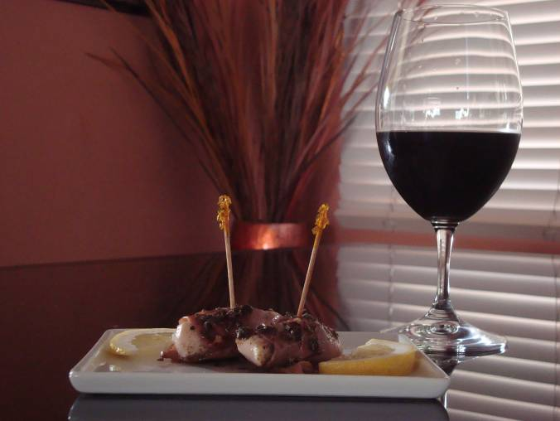
3 T. Sage, divided
1/8 t. Pepper
½ lb. Chicken Breasts, cut crosswise into pieces about 2” x 1”
¼ lb. Proscuitto Ham, cut into 1” wide strips
2 T. Butter, melted
1 T. Extra-virgin olive oil
2 T. red wine
2 T. Lemon juice
1 Lemon, sliced for garnish

Preheat oven to 450°. Sprinkle 2 tablespoons of the sage and the pepper onto the chicken pieces. Roll 1 strip of the prosciutto around the middle of the piece of chicken. Place seam side down in baking dish.

Scatter the remaining 1 tablespoon sage over rolls. Drizzle with melted butter and olive oil. Bake in oven for 4 minutes. Drizzle with red wine. Bake for 4 more minutes (or until internal temperature of chicken reaches 175°.

Skewer rolls with cocktail pick or skewer. Transfer to serving plate. Drizzle with lemon juice and pan juices. Garnish with slices of lemon.

