Arizona Wines
“It wasn’t until the 1970’s that the Arizona wine industry began an earnest growth. For the most part, Arizona is just too hot and dry to grow grapes with a long enough ripening season to produce decent wines. But locations with higher elevations and cooler temperatures have a chance at better grape balance and quality wines. For this reason, most of Arizona’s wineries are concentrated in these areas. The state’s only AVA, Sonoita, covers a large area in the southeast corner of the state, in the valleys at the slopes of the Santa Rita, Huachuca, and Whetsone mountains. In addition to the higher altitudes, this area also has free-draining soils, which also contribute to better fruit. The most successful varietals for this warm climate are Syrah, Grenache, Viognier, Zinfandel, Tempranillo, Sangiovese, Cabernet Sauvignon, and Muscat.”
– Description from Amanda Schuster

We just returned from a very relaxing vacation to Arizona. While on vacation we got to try some of Arizona's wines in the Verde Valley, just south of Sedona. Who knew that they are producing wine? Overall, the wines were very drinkable. The youth of the industry shows but I think the wines have potential. As in many other parts of the country, they source many of their grapes from California and have only a few estate wines.
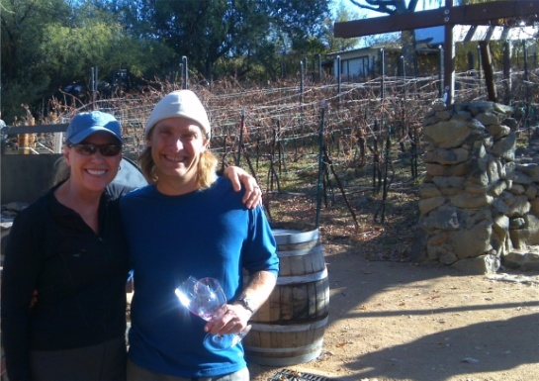
We briefly met the winemaker, Eric Glomski, at his winery, Page Springs Cellars. We also visited 2 other wineries-Javelina Leap & Oak Creek. Page Springs Cellars was the most picturesque of the wineries that we visited. We sat and ate our picnic lunch and enjoyed a bottle of their wine on a deck overlooking the river. It was so relaxing!

About Eric Glomski, Winemaker

(Above: Eric Glomski with our friend, Linda, at Page Springs Winery)
Eric is a "wine guru" and he has been instrumental in putting the Verde Valley on the winemaking map. He has a lot of passion about making wine.In the mid 90's he left Arizona for a few years and relocated to California to learn more about winemaking. He briefly worked harvest at Limerick Lane, a small Old Vine Zinfandel producer in Sonoma County California. After leaving Sonoma, Eric worked for several years at David Bruce Winery in the Santa Cruz Mountains. Working his way up from Cellar Worker, Assistant Production Manager, Production Manager and Assistant Winemaker over the course of five years. He became Co-Winemaker and Director of Production in 2001. During his tenure at David Bruce, Eric also pursued a great deal of coursework at the University of California at Davis in Viticulture and Enolog.
It was always his plan to move back to Arizona and he did so in 2003. In 2004, Eric and his family purchased the land on Oak Creek in the small village of Page Springs, just south of Sedona. This is where the Page Springs Cellars is now located. It is definitely a beautiful spot in one of the most scenic areas of the country.
When you are in Arizona, be sure to visit the Verde Valley and the Verde Valley Wine Trail. It is worth a visit for the scenery as well as the wine.

